Pandoc does org-mode now
John Kitchin

Pandoc does org-mode now
Pandoc (http://johnmacfarlane.net/pandoc/) is a document converter. It does a pretty good job of converting a document in one format to another. Pandoc also knows about org-mode now, and can convert an org-file to a Word document! We are going to test it out in this post to see what it does well with.

A subsection with some equations
Einstein showed us that $E=mc^{2}$.
A matrix looks like this:

A section with a figure
Here is a figure in the document.
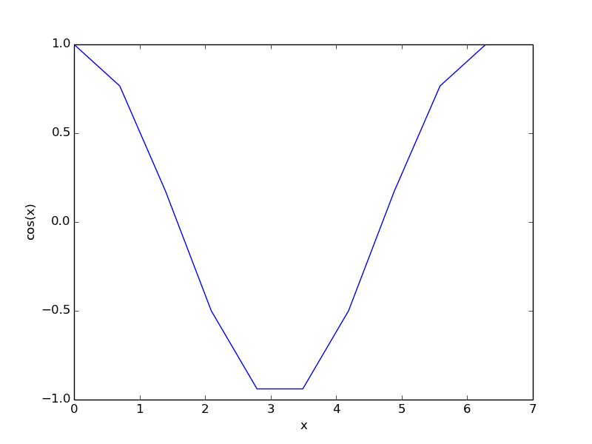

A section with a table
x | y
1 | 1
2 | 4
3 | 9
A simple table.

Some citations
For fun, a reference to the org-mode book cite:dominik-2010-org-mode.

some source code
here is a python block.
print 'hello pandoc'
hello pandoc
and finally, we write a block that will convert this file to a word document.
(save-buffer)
(shell-command "pandoc -s -s org-to-word.org -o org-to-word.docx")
1
Now, here is that file+sys:org-to-word.docx
it is pretty good, but not as good as the native org to pdf (file:org-to-word.pdf), but since the translation is happening outside of Emacs the results are still pretty impressive. The simple equation was translated to a Word equation format (cool!) but the matrix did not show up in the word document, nor did the figure caption. The code does show up, but the lines are not numbered as they are in the pdf. The citation did not work out of the box. The User guide suggests it might be possible to get this to work with a citations extension though.
I am impressed that the Word document has proper section headings. Overall, my impression is that this is a very good way to get 90+% of the way to a finished word document with an org-source file!

